Web data extraction Requirement document

Suggested Code Policy:

1. Copy the Project folder structure from bellow github link.

<https://github.com/hackathonScrapping/BANK.git>

1. Use Python(Mandatory) with BeautifulSoup, Scrapy and Selenium (Feel free to use any other Python libraries)
2. Store Scrapped data with provided file name and CSV format.

Work 1:

**Scarped Data Format (File Name - ALLY_Data_Deposit_<MM_DD_YYYY>.csv)**

|  |  |  |  |  |  |
| --- | --- | --- | --- | --- | --- |
| Date | Bank Name | TAB Name | Product Name | Minimum Opening Balance | APY |
|  |  |  |  |  |  |
|  |  |  |  |  |  |
|  |  |  |  |  |  |
|  |  |  |  |  |  |
|  |  |  |  |  |  |
|  |  |  |  |  |  |

|  |  |  |  |  |  |  |  |  |  |  |  |  |
| --- | --- | --- | --- | --- | --- | --- | --- | --- | --- | --- | --- | --- |
|  |  | |  |  |  |  |  |  | | | |  |
|  |  | |  |  |  |  |  |  | | | |  |
|  | |  | | | | | | | | | |  |
|  |  | |  |  |  | | | |  |  |  |  |

**Steps**

1. Click on below bank site

URL: <https://www.ally.com/bank/savings-account-rates/>

1. Click on each of the 3 tabs (Savings, CDs)
2. Scrape deposit account related data as per details provided below

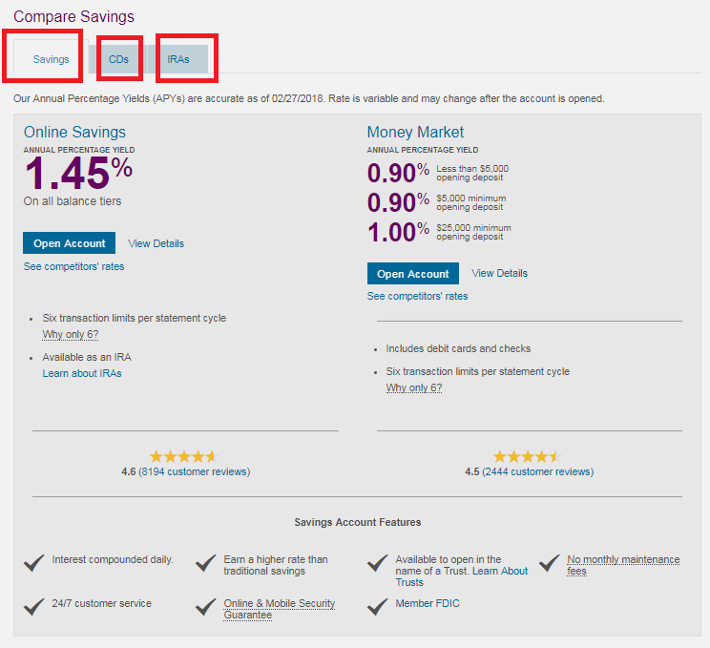

|  |  |  |  |  |  |  |  |  |  |  |  |  |  |  |  |  |  |
| --- | --- | --- | --- | --- | --- | --- | --- | --- | --- | --- | --- | --- | --- | --- | --- | --- | --- |
|  | |  |  | |  | |  | |  | |  | |  |  |  |  |  |
|  |  | | |  | |  | |  | |  | |  | | | | | |

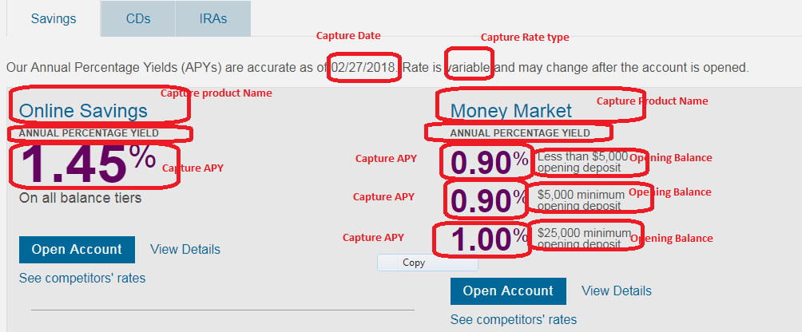

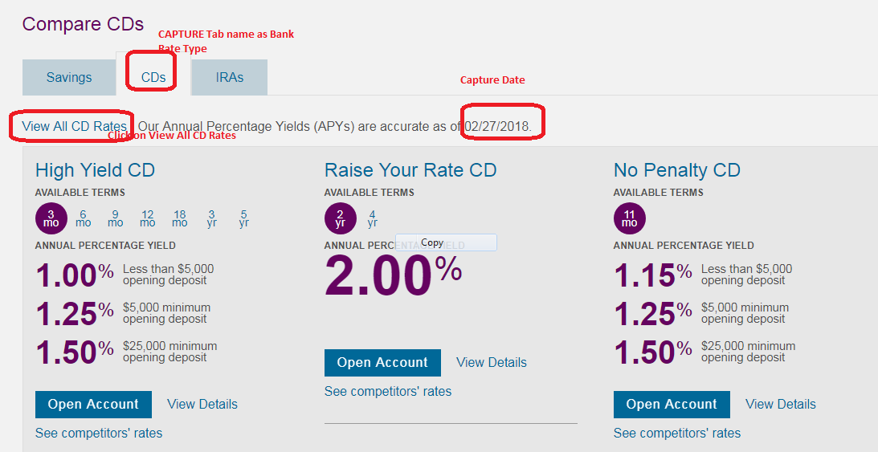

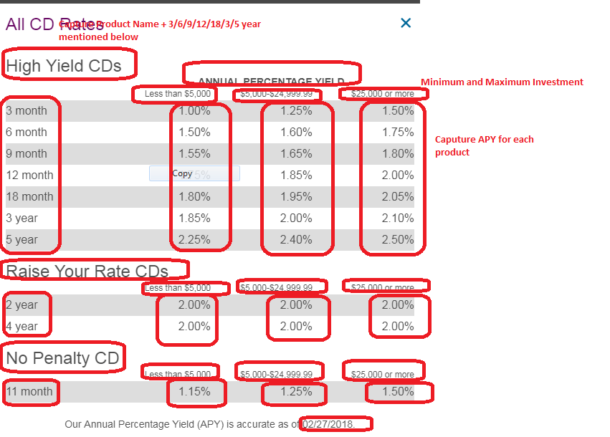

Work 2: Mortgage Rates

**Link:** [**https://www.ally.com/home-loans/mortgage/**](https://www.ally.com/home-loans/mortgage/)

**Scarped Data Format (File Name - ALLY_Data_Mortgage_<MM_DD_YYYY>.csv)**

|  |  |  |  |  |  |  |  |  |  |  |  |
| --- | --- | --- | --- | --- | --- | --- | --- | --- | --- | --- | --- |
| Date | Bank Name | Loan Rate Type | Product Name | Credit Score | city | Loan Amount | Tenor | Down Payment | Points | Interest Rate | APR |
|  |  | Fixed/Variable |  |  |  |  |  |  |  |  |  |
|  |  |  |  |  |  |  |  |  |  |  |  |
|  |  |  |  |  |  |  |  |  |  |  |  |
|  |  |  |  |  |  |  |  |  |  |  |  |
|  |  |  |  |  |  |  |  |  |  |  |  |
|  |  |  |  |  |  |  |  |  |  |  |  |

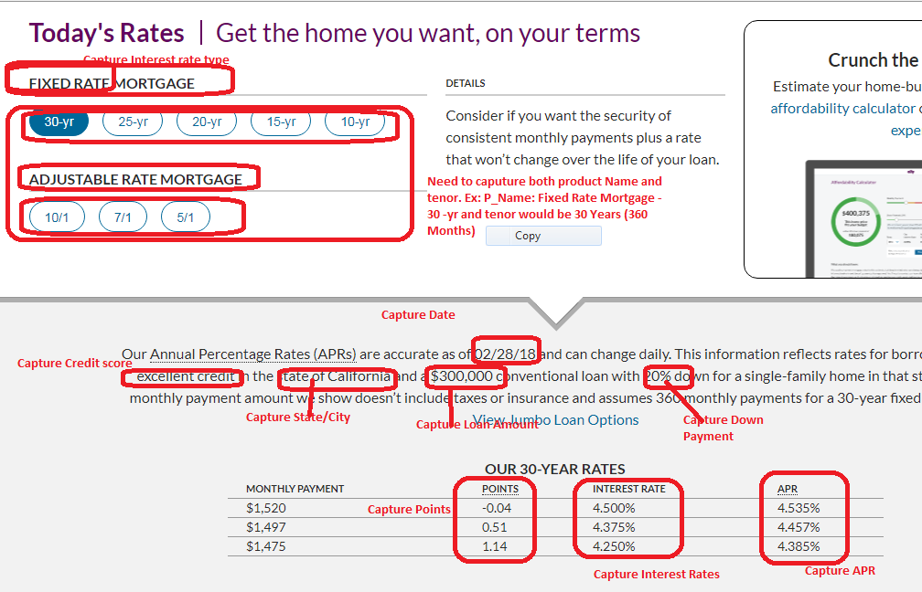

**Repeat above extract for all tabs**

